Database documentation

Picture 1: Conceptual Diagram of the Analysis

Picture 2: Javadiagram

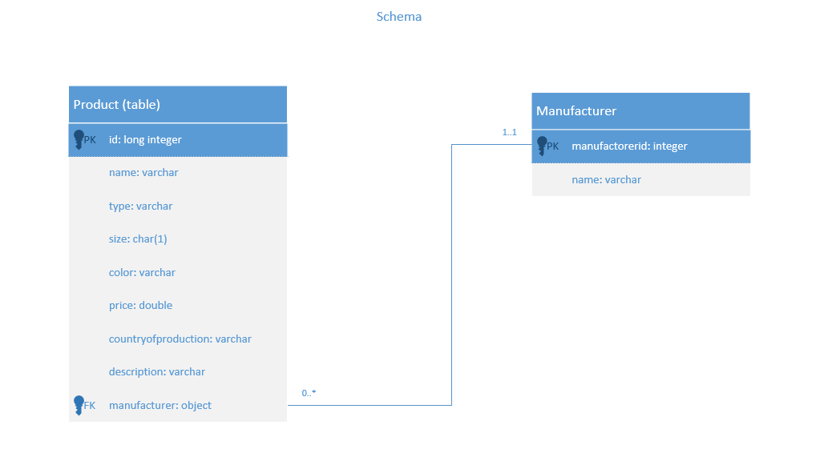

Picture 3: Schema

|  |  |
| --- | --- |
| **The title of the concept** | Manufacturer |
| **Definition:** | Manufacturer marked in the database |
| **Attributes:** | manufacturerid  name |
| **Identification:** | manufacturerid |

|  |  |
| --- | --- |
| **The title of the concept:** | Product |
| **Definition:** | Product sold on the online shop and produced by a specific manufacturer |
| **Attributes:** | id  name  type  size  color  price  country of production  description  manufacturer |
| **Identification:** | id |